Date ________________
Name of the Applicant
Address of the Applicant
Manager
_________________ Branch
Amana Bank PLC.

Dear Sir/Madam
Request for the Enrollment of Card Online Usage
I/We …………………(name in full)…………………bearer of NIC …………..and …………..joint accountholder……………………(name in full)……………..bearer of NIC………………hereby authorize and request Amãna Bank PLC to activate online usage for the Debit Card issued to the below mentioned customer identification number and hereby I agree to be bound by the terms & conditions of
- The Bank’s updated General Business Conditions as at July 2022, which was accessed through the Banks Website www.amanabank.lk
- The Bank’s Email Indemnity Conditions and the Banks E-Banking Terms & Conditions, which was accessed by me through the Banks website www.amanabank.lk , which I have read, understood and agreed.
Account Number | Card Number

Please register my E-mail address:

Please assign me the below limit profile. (Limit category should be selected from the below table)
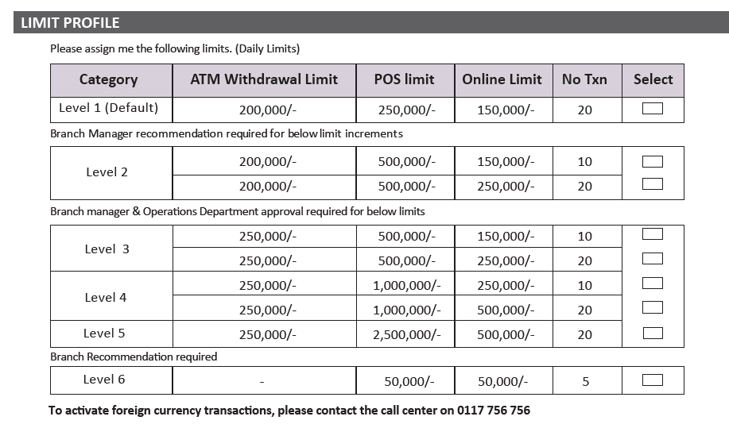
Thank you
……………………………………………………………………….
Signature of the account holder/s

